LAPORAN TUGAS
WORKSHOP SISTEM INFROMASI WEB SERVER
(TIF330805)
MINGGU KE-3 Pertemuan 2
SEMESTER III



ACARA 6
Middleware, Auth Sederhana, dan Struktur Folder Lengkap

Disusun Oleh :

Rezza Wahyu Setya Adhy (E41250211)
Golongan A

PROGRAM STUDI DI LUAR KAMPUS UTAMA (PSDKU)
TEKNIK INFORMATIKA KAB. NGANJUK
JURUSAN TEKNOLOGI INFORMASI
POLITEKNIK NEGERI JEMBER
TAHUN 2026
- Studi Kasus
Halaman dashboard, form tambah mahasiswa, dan halaman edit hanya boleh diakses user yang sudah login. Tanpa proteksi, siapa pun yang tahu URL bisa masuk. Middleware Auth mengecek session sebelum Controller dijalankan. Jika belum login, user diarahkan ke halaman login.
- Tujuan
Mahasiswa menyusun struktur folder lengkap, membuat AuthController (login/logout), dan melindungi beberapa route dengan AuthMiddleware.
- Langkah
- Susun folder sesuai struktur di atas.
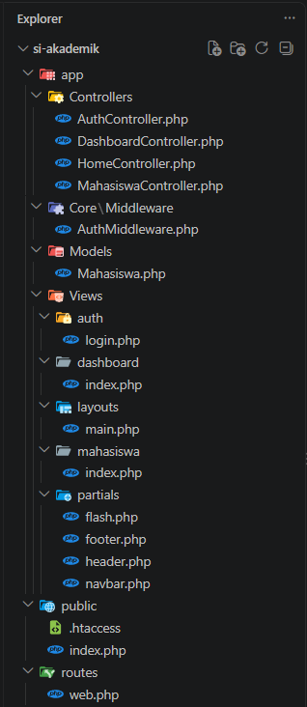
- Buat AuthController dengan method loginForm, login, logout.
- app/Controllers/AuthController.php
<?php

namespace App\Controllers;

class AuthController
{
public function loginForm(): void
{
// Kalau sudah login, tidak perlu lihat form login lagi
if (!empty($_SESSION['logged_in'])) {
header('Location: /acara6/si-akademik/public/dashboard');
exit;
}

$error = $_SESSION['error'] ?? null;
unset($_SESSION['error']);

$content = __DIR__ . '/../Views/auth/login.php';
require __DIR__ . '/../Views/layouts/main.php';
}

public function login(): void
{
$username = trim($_POST['username'] ?? '');
$password = $_POST['password'] ?? '';

// Login disimulasikan dengan hardcode (nanti diganti database)
if ($username === 'admin' && $password === 'admin123') {
session_regenerate_id(true);
$_SESSION['logged_in'] = true;
$_SESSION['user_id'] = 1;
$_SESSION['user_name'] = 'Admin';

header('Location: /acara6/si-akademik/public/dashboard');
exit;
}

$_SESSION['error'] = 'Username atau password salah';
header('Location: /acara6/si-akademik/public/login');
exit;
}

public function logout(): void
{
$_SESSION = [];
session_destroy();

header('Location: /acara6/si-akademik/public/login');
exit;
}
}

- Buat form login sederhana.
- app/Views/auth/login.php
<div class="row justify-content-center">
<div class="col-md-4">
<h5 class="mb-3">Login</h5>

<?php if (!empty($error)): ?>
<div class="alert alert-danger"><?= htmlspecialchars($error) ?></div>
<?php endif; ?>

<form action="/acara6/si-akademik/public/login" method="POST">
<div class="mb-3">
<label class="form-label">Username</label>
<input type="text" name="username" class="form-control" required>
</div>
<div class="mb-3">
<label class="form-label">Password</label>
<input type="password" name="password" class="form-control" required>
</div>
<button type="submit" class="btn btn-primary w-100">Login</button>
</form>
</div>
</div>

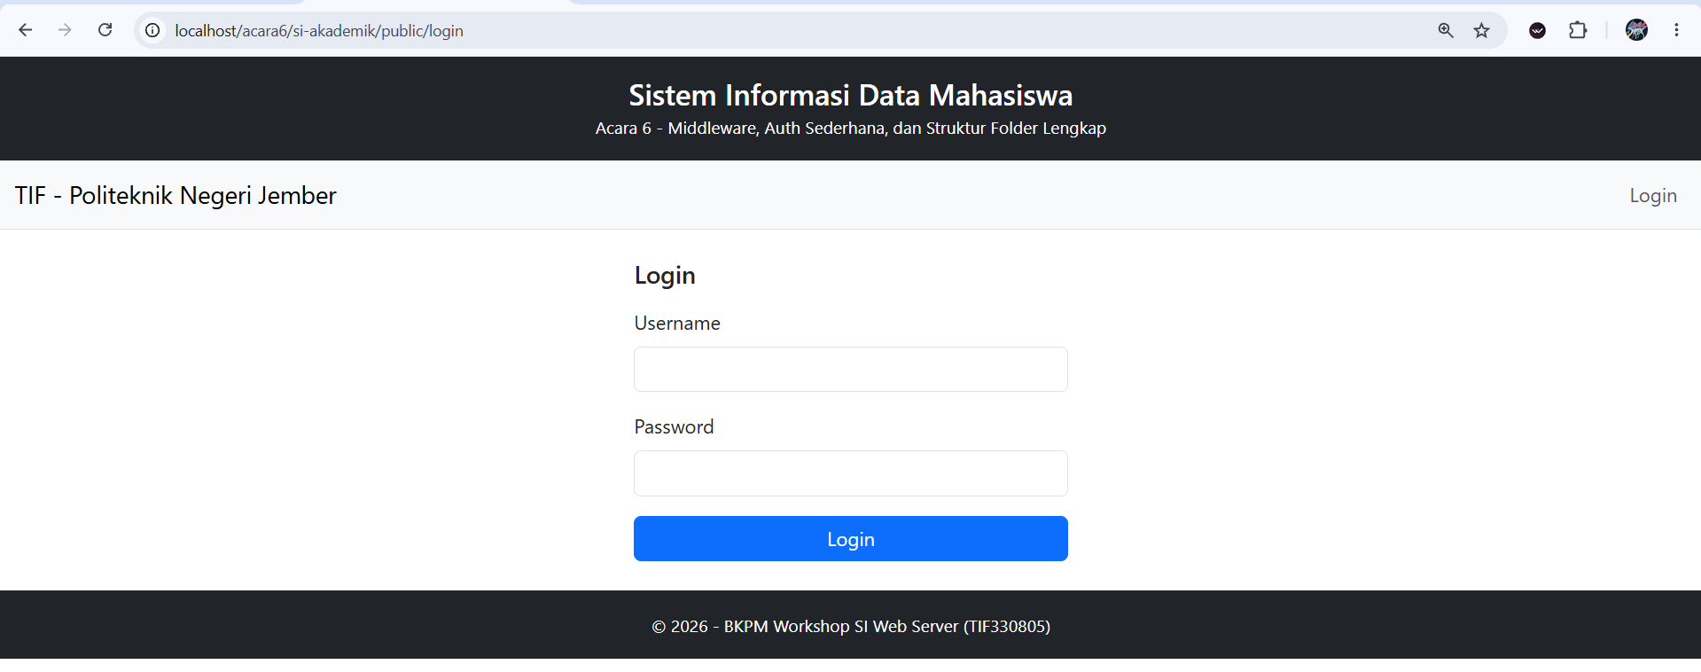

- Simulasikan login sukses dengan hardcode username/password dulu (nanti diganti database).
- Login
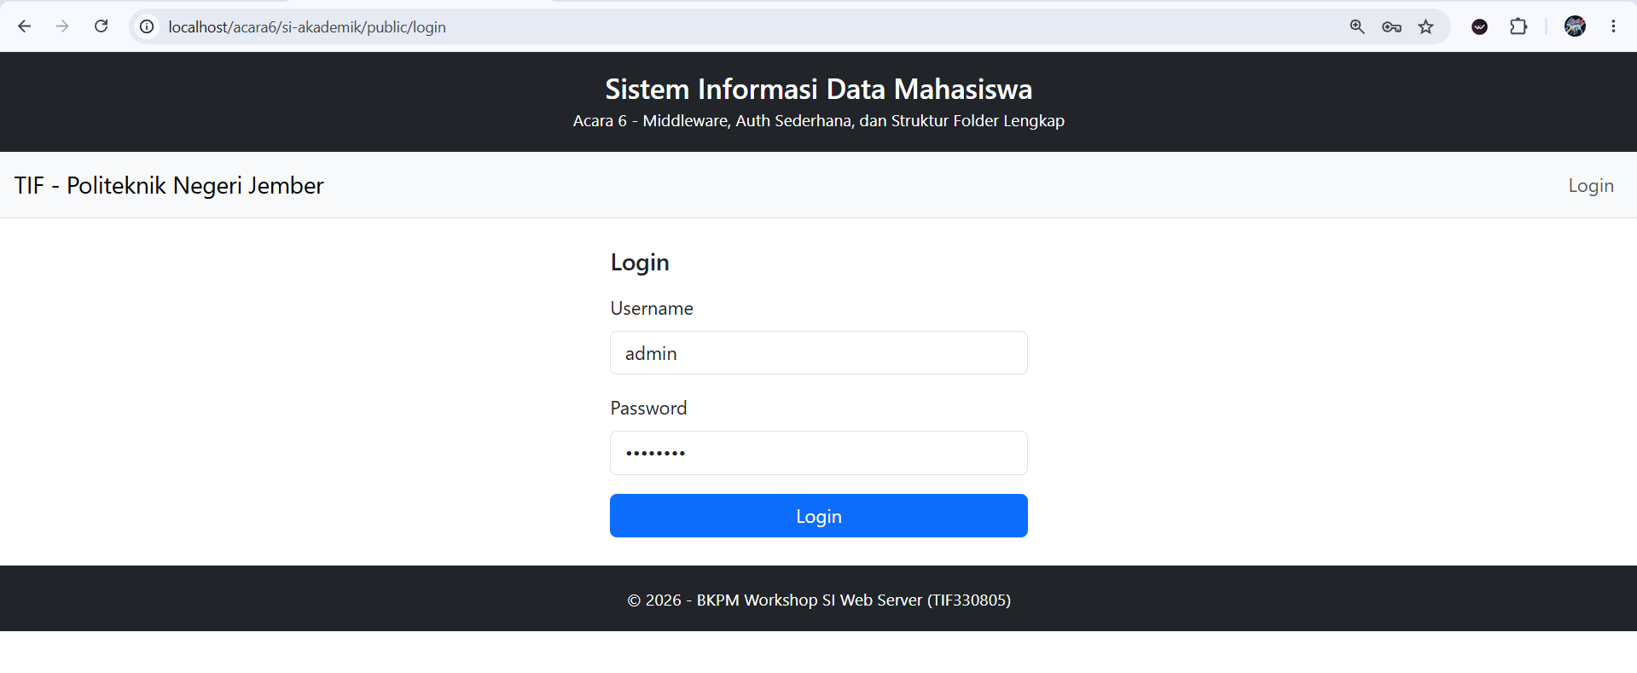
- Login Berhasil
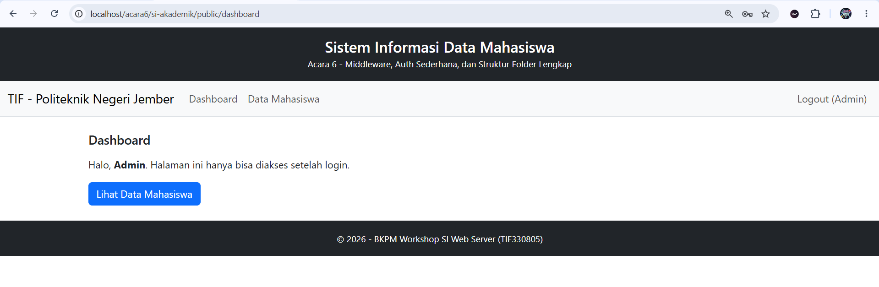
- Pasang AuthMiddleware pada route /dashboard dan /mahasiswa.
- app/Core/Middleware/AuthMiddleware.php
<?php

namespace App\Core\Middleware;

class AuthMiddleware
{
public function handle(): void
{
if (session_status() === PHP_SESSION_NONE) {
session_start();
}

if (empty($_SESSION['logged_in']) || $_SESSION['logged_in'] !== true) {
header('Location: /acara6/si-akademik/public/login');
exit;
}
}
}

- routes/web.php
<?php

use App\Core\Middleware\AuthMiddleware;

$routes = [
'GET' => [
'/' => ['HomeController', 'index'],
'/login' => ['AuthController', 'loginForm'],
'/logout' => ['AuthController', 'logout'],
'/dashboard' => ['DashboardController', 'index', 'middleware' => [AuthMiddleware::class]],
'/mahasiswa' => ['MahasiswaController', 'index', 'middleware' => [AuthMiddleware::class]],
'/mahasiswa/create' => ['MahasiswaController', 'create', 'middleware' => [AuthMiddleware::class]],
],
'POST' => [
'/login' => ['AuthController', 'login'],
'/mahasiswa' => ['MahasiswaController', 'store', 'middleware' => [AuthMiddleware::class]],
],
];
- public/index.php
<?php
session_start(); // harus dipanggil sebelum ada output

require_once __DIR__ . '/../app/Models/Mahasiswa.php';
require_once __DIR__ . '/../app/Core/Middleware/AuthMiddleware.php';
require_once __DIR__ . '/../app/Controllers/HomeController.php';
require_once __DIR__ . '/../app/Controllers/AuthController.php';
require_once __DIR__ . '/../app/Controllers/DashboardController.php';
require_once __DIR__ . '/../app/Controllers/MahasiswaController.php';
require_once __DIR__ . '/../routes/web.php';

use App\Core\Middleware\AuthMiddleware;

$uri = parse_url($_SERVER['REQUEST_URI'], PHP_URL_PATH);

$base = '/acara6/si-akademik/public';
if (str_starts_with($uri, $base)) {
$uri = substr($uri, strlen($base)) ?: '/';
}

$method = $_SERVER['REQUEST_METHOD'];

// 1. Cari route
$route = $routes[$method][$uri] ?? null;
$params = [];

// Dari Acara 5 (tugas mandiri): parameter URL /mahasiswa/5 -> show($id)
if ($route === null && $method === 'GET' && preg_match('#^/mahasiswa/(\d+)$#', $uri, $cocok)) {
$route = ['MahasiswaController', 'show', 'middleware' => [AuthMiddleware::class]];
$params = [(int) $cocok[1]];
}

// 2. Tidak ketemu -> 404
if ($route === null) {
http_response_code(404);
echo "404 - Halaman tidak ditemukan";
exit;
}

// 3. Jalankan middleware (jika ada) sebelum controller
foreach ($route['middleware'] ?? [] as $mw) {
$mwInstance = new $mw();
$mwInstance->handle();
}

// 4. Panggil controller
$controllerClass = "App\\Controllers\\{$route[0]}";
$controller = new $controllerClass();
$controller->{$route[1]}(...$params);

- Uji: akses /mahasiswa tanpa login harus redirect ke /login.

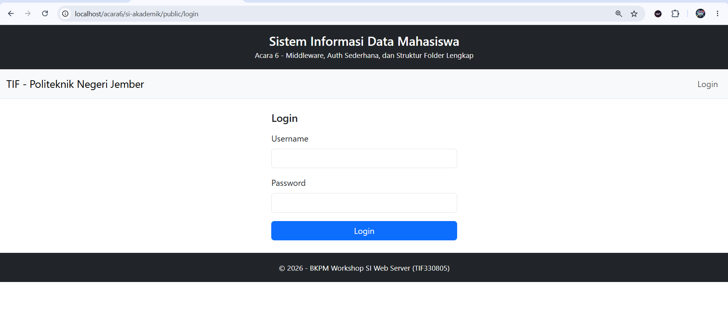

- Tugas Mandiri
Tambahkan flash message: setelah login sukses, tampilkan alert "Selamat datang, Admin" di dashboard. Setelah logout, tampilkan "Anda telah logout".
- app/Views/partials/flash.php
<?php if (!empty($_SESSION['flash'])): ?>
<div class="alert alert-<?= htmlspecialchars($_SESSION['flash']['type']) ?>" role="alert">
<?= htmlspecialchars($_SESSION['flash']['message']) ?>
</div>
<?php unset($_SESSION['flash']); // hanya tampil sekali ?>
<?php endif; ?>
- app/Views/layouts/main.php
<!DOCTYPE html>
<html lang="id">
<head>
<meta charset="UTF-8">
<title>Data Mahasiswa - Acara 6</title>
<link rel="stylesheet" href="https://cdn.jsdelivr.net/npm/bootstrap@5.3.3/dist/css/bootstrap.min.css">
</head>
<body>
<?php include __DIR__ . '/../partials/header.php'; ?>
<?php include __DIR__ . '/../partials/navbar.php'; ?>
<main class="container mt-4">
<?php include __DIR__ . '/../partials/flash.php'; ?><!-- ===== TUGAS MANDIRI ===== -->
<?php require $content; ?>
</main>
<?php include __DIR__ . '/../partials/footer.php'; ?>
</body>
</html>
- app/Controllers/AuthController.php
<?php

namespace App\Controllers;

class AuthController
{
public function loginForm(): void
{
// Kalau sudah login, tidak perlu lihat form login lagi
if (!empty($_SESSION['logged_in'])) {
header('Location: /acara6/si-akademik/public/dashboard');
exit;
}

$error = $_SESSION['error'] ?? null;
unset($_SESSION['error']);

$content = __DIR__ . '/../Views/auth/login.php';
require __DIR__ . '/../Views/layouts/main.php';
}

public function login(): void
{
$username = trim($_POST['username'] ?? '');
$password = $_POST['password'] ?? '';

// Login disimulasikan dengan hardcode (nanti diganti database)
if ($username === 'admin' && $password === 'admin123') {
session_regenerate_id(true);
$_SESSION['logged_in'] = true;
$_SESSION['user_id'] = 1;
$_SESSION['user_name'] = 'Admin';

// ===== TUGAS MANDIRI =====
$_SESSION['flash'] = [
'type' => 'success',
'message' => 'Selamat datang, ' . $_SESSION['user_name'],
];
// ===== AKHIR TUGAS MANDIRI =====

header('Location: /acara6/si-akademik/public/dashboard');
exit;
}

$_SESSION['error'] = 'Username atau password salah';
header('Location: /acara6/si-akademik/public/login');
exit;
}

public function logout(): void
{
$_SESSION = [];
session_destroy();

// ===== TUGAS MANDIRI =====
// session_destroy() menghapus semua data, jadi buka session baru untuk pesan
session_start();
session_regenerate_id(true);
$_SESSION['flash'] = [
'type' => 'info',
'message' => 'Anda telah logout',
];
// ===== AKHIR TUGAS MANDIRI =====

header('Location: /acara6/si-akademik/public/login');
exit;
}
}
- Output
- Sesudah login
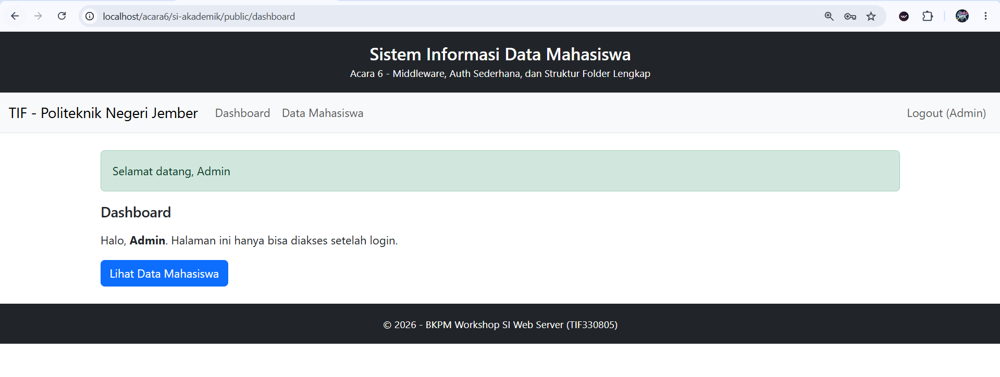
- Setelah di refresh
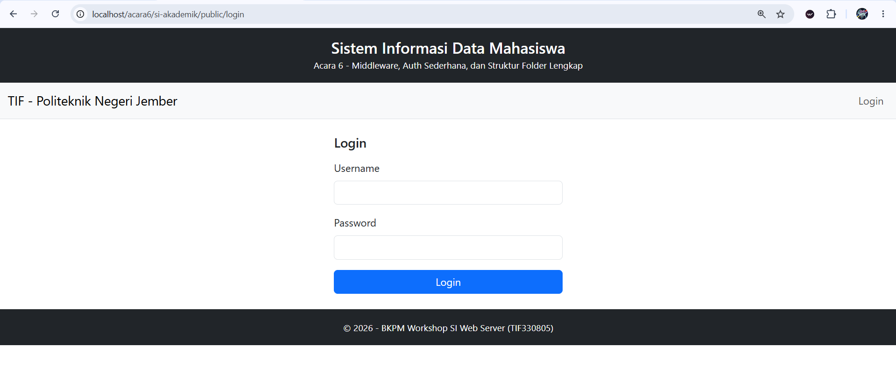
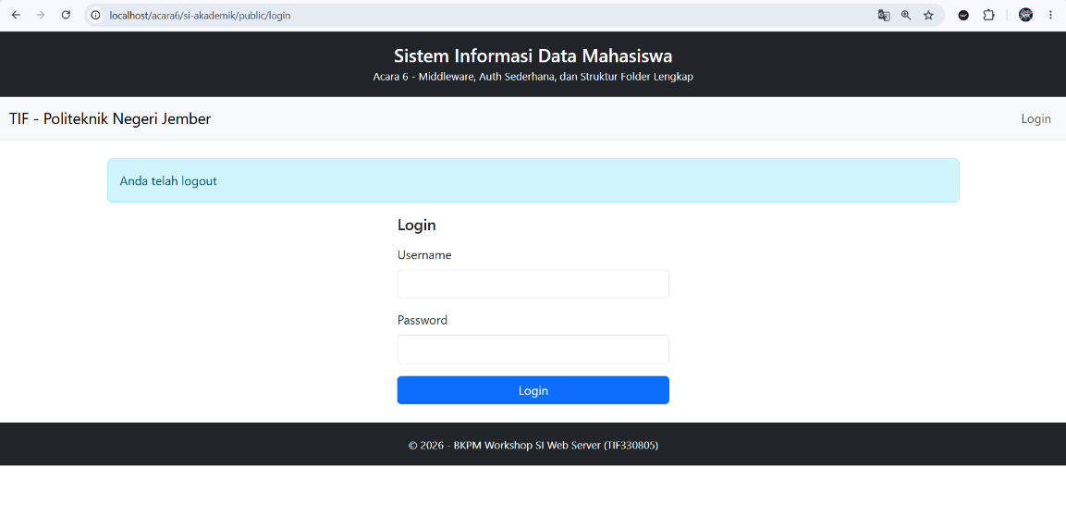
- Tampilan setelah logout

